Software Requirements Specification

Dimensioning Tool

(AvidBeam Solutions)

Version 1.0 approved

Prepared by Ahmed Sobhi

AvidBeam – Software Engineer

March 30th, 2017

Table of Contents

Table of Contents 1

Revision History 1

1. Introduction 3

1.1 Purpose 3

1.2 Document Conventions 3

1.3 Intended Audience and Reading Suggestions 4

1.4 Product Scope 4

1.5 References 5

2. Overall Description 6

2.1 Product Perspective 6

2.2 Product Functions 6

2.3 User Classes and Characteristics 6

2.4 Operating Environment 6

2.5 Design and Implementation Constraints 6

2.6 User Documentation 7

2.7 Assumptions and Dependencies 7

3. External Interface Requirements 8

3.1 User Interfaces 8

3.2 Hardware Interfaces 10

3.3 Software Interfaces 10

3.4 Communications Interfaces 10

4. System Features 11

4.1 Add new Computing module 11

4.2 Remove existing computing module 11

4.3 Edit Computing Module 12

4.4 New Deployment 12

4.5 Remove existing Deployment 13

4.6 Media Source Configuration 13

4.7 Add Media Source 14

4.8 Remove Media Source 14

4.9 Calculate Hardware estimate 15

4.10 Calculate Hardware Configuration recommendation 15

5. Other Nonfunctional Requirements 16

5.1 Performance Requirements 16

5.2 Safety Requirements 16

5.3 Security Requirements 16

5.4 Software Quality Attributes 16

5.5 Business Rules 16

6. Other Requirements 16

Revision History

|  |  |  |  |
| --- | --- | --- | --- |
| **Name** | **Date** | **Reason For Changes** | **Version** |
| Ahmed Sobhi | March 30th, 2017 | Initial Document in IEEE Format | 0.1 |

# Introduction

## Purpose

This PRD contains both functional and non-functional requirements that shall govern the development and release of all product components and collateral distributed for all AvidBeam products.

This PRD provides the product development team with the information necessary to understand and design the product and plan for project management. It also provides a basis to plan for implementation of the product and its support. The requirements recorded here are considered the “Plan of Record” (POR) once the document has reached revision level 0.80.

## Document Conventions

|  |  |
| --- | --- |
| Priority Code | Definition |
| 0 | Critical (must have) |
| 1 | Important (Good to have) |
| 2 | medium (nice to have) |
| 3 | low (could be added if schedule permits) |

|  |  |  |
| --- | --- | --- |
| Release Tags | Definition | Date |
| R0 | First release for internal & field testing |  |
| R1 |  |  |
| R2 |  |  |

|  |  |
| --- | --- |
| Color Code | Definition |
| Green | Completed (in previous releases) |
| Blue | approved for current release |
| Red | require extra investigation |
| Yellow | un-approved requirements (added after review meetings) |

## Intended Audience and Reading Suggestions

The PRD is intended for the following audiences and purposes:

* Customers use the PRD to understand the feature set of the product.
* Engineers refer to it as they create a high-level design (including user interface) based on requirements.
* Functional area managers and the Program Manager use it to help estimate resource needs and schedules and identify risks for the Program Management Plan.
* Quality Assurance and Test engineers use it to set quality criteria and plan for testing.
* Writers use it to plan product documentation.
* Marketing uses it to plan how the organization shall launch and sell the product.
* Product Support engineers use it to plan how the product shall be supported.

The approved PRD serves as a reference for the project team and internal suppliers to develop a product that adheres to the product requirements. PRD updates shall be communicated to the entire project team.

## Product Scope

This SRS is intended to only define what the functional and nonfunctional requirements of AvidBeam Dimensioning tool and not any of the other modules it is affected by (i.e. People Count, Analytics, Heat Maps, Pathways, LPR, ATUN, etc…).

## References

### People Count – PRD.doc

### LPR Engine – PRD.doc

### ViBE-P Installation Configuration.doc

### ViBE-P SRS. doc

### People Count Installation Instruction.doc

### ViBE-R Installation Configurations.doc

### ViBE-R SRS.doc

### Camera Specification for Computer Vision Algorithms by AvidBeam.doc

### AvidBeam Licensing Server.doc

### ATUN DSRD.doc

# Overall Description

## Product Perspective

The Dimensioning tool is a separate aggregator that is entitled to enable AvidBeam and external customers get a hardware estimate running their plugins over ATUN or running AvidBeam’s plugins or Software of ViBE family products or DiVA family products.

The Dimensioning tool is a complex tool that should enable its users to create a distinction between the different installation/deployment options of all software products created by AvidBeam or third-party integrators/developers.

The Dimensioning tool will always need updates and upgrades for the recommendations based on the hardware refresh cycles and advancements, it is also impacted by the underlying Engine(s) performance numbers.

## Product Functions

The Dimensioning tool is required to provide its users with the estimated hardware and its classification/ordering, this tool is aimed to be bullet proof and straight forward to use, it doesn’t need to be deeply modified, and should be self explanatory.

## User Classes and Characteristics

* AvidBeam Employees
* External Third-party contractors
* External Third-party system integrators
* AvidBeam trusted partners
* Third-party Software developers that needs to integrate their code within ATUN

## Operating Environment

Dimensioning tool is a web based tool that runs over a webserver (nginx) and is hosted on AvidBeam website once development is complete. This entails by default that it is running over Ubuntu 14.04 linux 64-bit OS. Choice of Database engine has not been determined.

## Design and Implementation Constraints

Dimensioning tool should run all communication and data in a secure manner using TLS/SSL encryption over AES-256.

## User Documentation

Dimensioning tool as all AvidBeam products will have the following accompanying user documents:

1. Release Notes
2. User Guide
3. Installation Guide
4. Onsite Training from AvidBeam professionals

## Assumptions and Dependencies

<NONE>

# External Interface Requirements

## User Interfaces

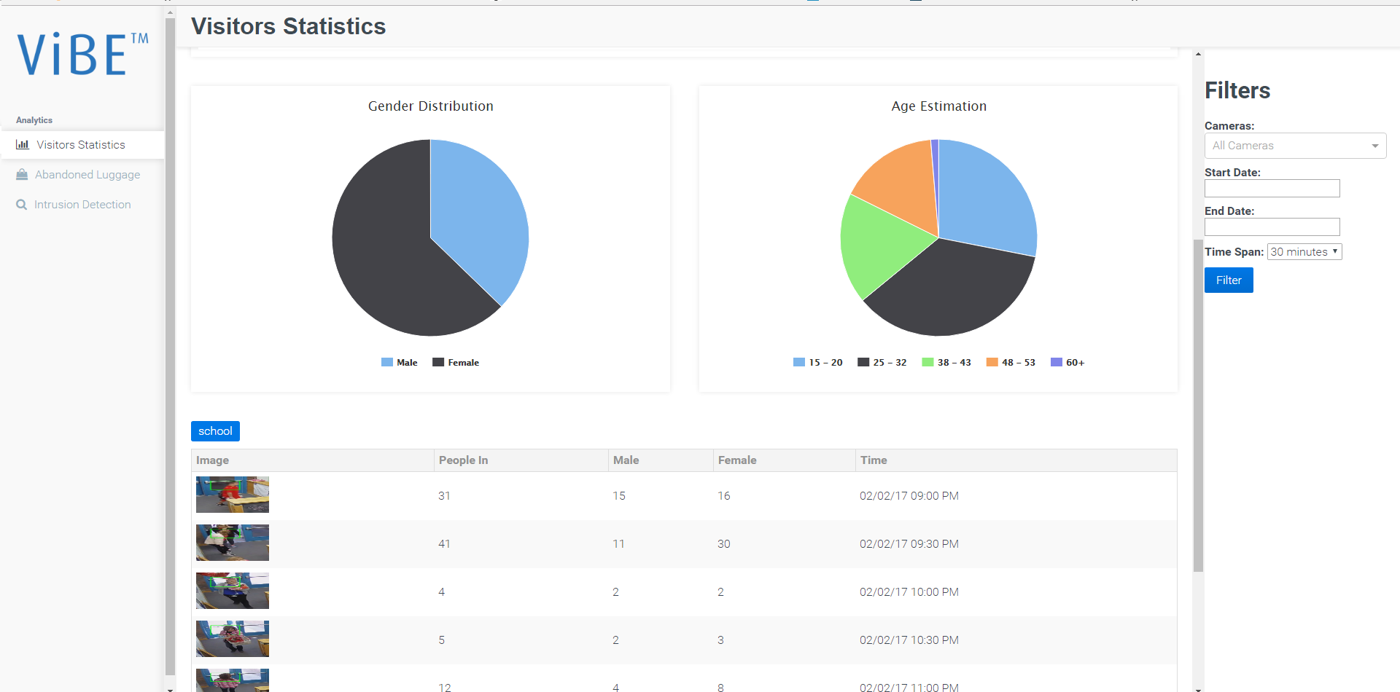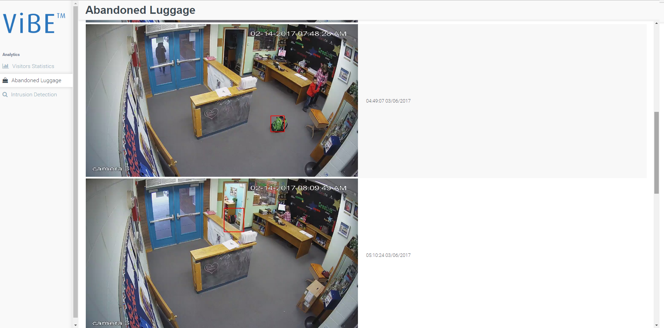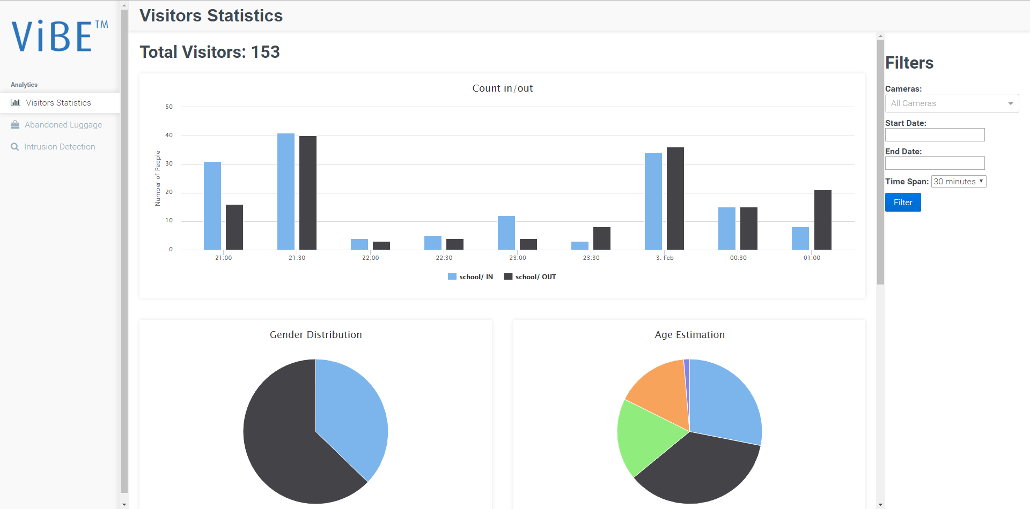

## 

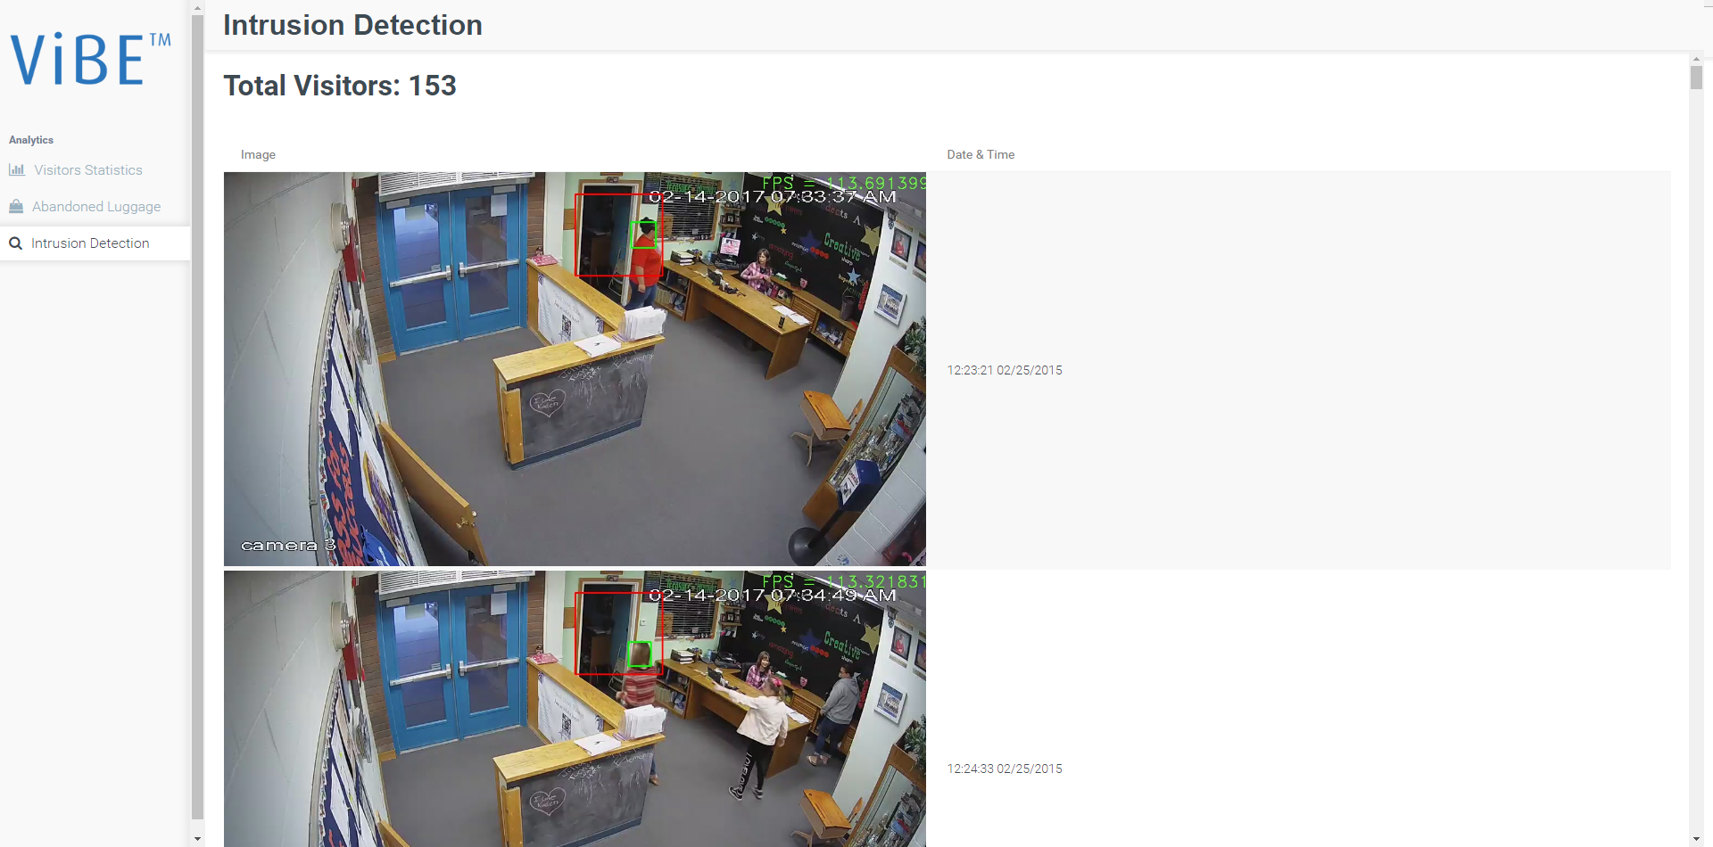

## Hardware Interfaces

<NONE>

## Software Interfaces

The Dimensioning tool is a web based tool and utilizes different frameworks and stacks to provide the best user experience with the best preference.

The table below describes third-party software used within the development of the product

|  |  |  |  |  |
| --- | --- | --- | --- | --- |
| **ID** | **Product Name** | **Version** | **Description** | **Reference Link** |
| **1** |  |  |  |  |
| **2** |  |  |  |  |
| **3** |  |  |  |  |
| **4** |  |  |  |  |
| **5** |  |  |  |  |
| **6** |  |  |  |  |
| **7** |  |  |  |  |
| **8** |  |  |  |  |
| **9** |  |  |  |  |
| **10** |  |  |  |  |
| **11** |  |  |  |  |
| **12** |  |  |  |  |

## Communications Interfaces

The tool communicates over the following set of protocols and ports:

* TCP/9090/Thrift
* TCP/9001/HTTP
* TCP/80/HTTP
* TCP/3001/HTTP
* TCP/5555/ZeroMQ
* TCP/2701/MongoDB
* TCP/3306/MySQL

# System Features

## Add new Computing module

### Description and Priority

The Administrator should be able to add a new computing module, this algorithm’s computing parameters are the required input to compute the estimated hardware

### Stimulus/Response Sequences

* The Administrator user logs in with their correct credentials
* The admin user goes to the Computing modules menu
* The admin user clicks on Add new Computing module
* The admin user is prompted with a menu to add the Algorithm configuration parameters to the system (i.e. algorithm name, algorithm RAM requirements, algorithm computing power –Threads, cores, physical cores count -, max input resolution, max supported framerate, Algorithm processing FPS, Algorithm version)
* The admin user then clicks on add/save button
* The admin user is then directed to all the Computing modules presented in the system window

### Functional Requirements

<TBD>

## Remove existing computing module

### Description and Priority

The system administrator should be able to remove an existing computing module from the system

### Stimulus/Response Sequences

* The Administrator user logs in with their correct credentials
* The admin user goes to the computing modules menu
* The admin user selects the computing module to be removed
* The admin user click on remove algorithm
* The admin user is prompted with a confirmation message to remove the selected module
* The admin user then clicks on yes button
* The admin user is then directed to all the module presented in the system window, without the algorithm just deleted.

### Functional Requirements

<TBD>

## Edit Computing Module

### Description and Priority

The system user should be able to edit/alter the details of a module, because of enhancements or feature additions to the module

### Stimulus/Response Sequences

* The user logs in with their correct credentials
* The user goes to the computing modules menu
* The user selects the desired module to change configuration for
* The user clicks the edit button
* The user is then prompted with a menu to edit the module configuration
* The user then clicks on save/update button
* The user now finds the updated configuration to the module changed applied and results reflect that change

### Functional Requirements

<Itemize the detailed functional requirements associated with this feature. These are the software capabilities that must be present in order for the user to carry out the services provided by the feature, or to execute the use case. Include how the product should respond to anticipated error conditions or invalid inputs. Requirements should be concise, complete, unambiguous, verifiable, and necessary. Use “TBD” as a placeholder to indicate when necessary information is not yet available.>

## New Deployment

### Description and Priority

The system user should be able to create a new deployment scenario and add all the required features and number of streams selecting the computing modules, after all computing modules are selected, the user should be able to calculate the estimated hardware.

### Stimulus/Response Sequences

* The user logs in with their correct credentials
* The user goes to the Deployments menu
* The user clicks on Add new Deployment
* The user is prompted with a menu to add the deployment configuration parameters to the system ( Deployment name, number of streams, streams configuration parameters )
* The user then clicks on add/save button
* The user is then directed to all the deployment scenarios owned by the user presented in the system window.

### Functional Requirements

<Itemize the detailed functional requirements associated with this feature. These are the software capabilities that must be present in order for the user to carry out the services provided by the feature, or to execute the use case. Include how the product should respond to anticipated error conditions or invalid inputs. Requirements should be concise, complete, unambiguous, verifiable, and necessary. Use “TBD” as a placeholder to indicate when necessary information is not yet available.>

## Remove existing Deployment

### Description and Priority

The system user should be able to remove an existing deployment scenario from the system.

### Stimulus/Response Sequences

* The user logs in with their correct credentials
* The user goes to the deployments menu
* The user clicks on the desired scenario to be removed
* The user clicks on remove button

### Functional Requirements

<TBD>

## Media Source Configuration

### Description and Priority

The system user should be able to assign particular computing modules to a specific media stream

### Stimulus/Response Sequences

* The user logs in with their correct credentials
* The user goes to the deployment scenarios menu
* The user selects the desired scenario and clicks on it
* The user should find a list of media sources added to this scenario
* The user is prompted with a menu of media source configuration parameters to set

### Functional Requirements

## Add Media Source

### Description and Priority

The system should enable the user to new media source to an existing deployment scenario

### Stimulus/Response Sequences

* The user logs in with their correct credentials
* The user navigates to the deployment scenarios menu
* The user clicks on a desired deployment scenario
* The user then clicks on add media source button
* The user is prompted with a menu of media source configuration

### Functional Requirements

<TBD>

## Remove Media Source

### Description and Priority

The system should enable the users to remove a desired media source from a deployment scenario

### Stimulus/Response Sequences

* The user logs in with their correct credentials
* The user navigates to the deployment scenarios menu
* The user clicks on a desired deployment scenario
* The user then clicks on remove media source button
* The user is prompted with confirmation message
* On clicking yes, the user is redirected to a list of the available media sources

### Functional Requirements

<TBD>

## Calculate Hardware estimate

### Description and Priority

The system should enable the users to generate PDF reports of their estimated hardware configuration, in terms of RAM, CPU core counts, Storage size

### Stimulus/Response Sequences

* The user logs in with their correct credentials
* The user goes to the deployment scenarios menu
* The user clicks on the desired scenario to calculate the hardware estimate for
* The user clicks on calculate hardware estimate
* The user is then redirected to a new window with the PDF report to the amount of RAM, CPU Core Count and Storage size.

### Functional Requirements

## Calculate Hardware Configuration recommendation

### Description and Priority

The system should be able to calculate the hardware configuration recommended to the system to function properly, recommendations are based on grouping/clustering of information, in a form of (2x Servers (2x Xeon Processor 8 core –HT enabled 16 threads-, 2x 16 GB RAM, 500GB HDD/SSD) in PDF format.

### Stimulus/Response Sequences

* The user logs in with their correct credentials
* The user goes to the deployment scenarios menu
* The user clicks on the desired deployment scenario
* The user clicks on Generate HW Configuration Recommendation button
* The user is then redirected to a new window with the PDF report of the recommended HW configuration to be used with that scenario

### Functional Requirements

<TBD>

# Other Nonfunctional Requirements

## Performance Requirements

The Dimensioning tool should compute and generate the PDF in time less than 10 seconds

## Safety Requirements

The Dimensioning tool should compute workloads based on 60-80% CPU utilization and the estimated hardware as minimum requirements and not as the ideal scenario of deployment, this is due to massive H/W enhancements that occur from one generation to the next.

## Security Requirements

The system should be communicating over secure protocols and using enterprise grade encryption for user privacy and the privacy of the guests/visitors as well. Standards such as SSL/TLS/AES-256 encryption techniques should be used for all communication channels required, within the system or through the dedicated APIs without impacting on performance, accuracy or system stability.

## Software Quality Attributes

<Specify any additional quality characteristics for the product that will be important to either the customers or the developers. Some to consider are: adaptability, availability, correctness, flexibility, interoperability, maintainability, portability, reliability, reusability, robustness, testability, and usability. Write these to be specific, quantitative, and verifiable when possible. At the least, clarify the relative preferences for various attributes, such as ease of use over ease of learning.>

## Business Rules

<List any operating principles about the product, such as which individuals or roles can perform which functions under specific circumstances. These are not functional requirements in themselves, but they may imply certain functional requirements to enforce the rules.>

# Other Requirements

<Define any other requirements not covered elsewhere in the SRS. This might include database requirements, internationalization requirements, legal requirements, reuse objectives for the project, and so on. Add any new sections that are pertinent to the project.>